2025 W2 Forms in Dayforce
W2 forms are ready and will be mailed to your address on file. For security and privacy concerns we cannot send W2 forms through email.
You can also access them today in Dayforce
https://sso.dayforcehcm.com/crengland
- choose driver login
- enter your Driver code and password
  - default is initials and last 4 of SS (Example ME5555 or me5555 try both uppercase and lowercase)
- Once in Dayforce click on the Earnings icon
- Select the applicable Years w2 form to download or print
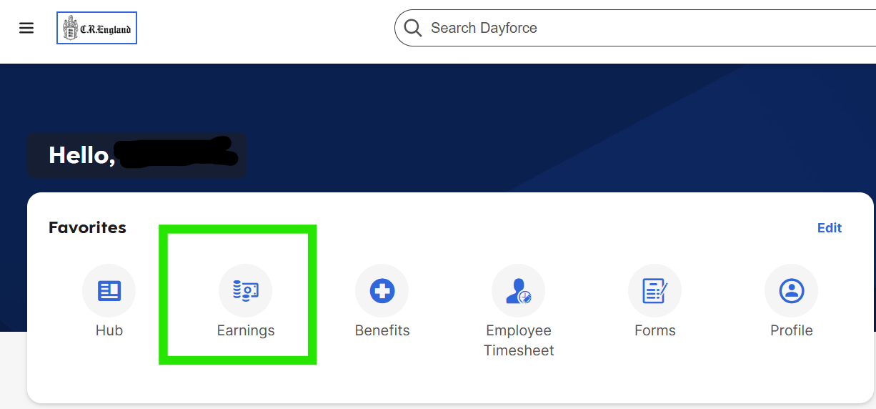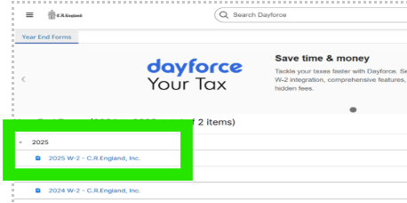

If on a Phone or Tablet, Scroll to the far right to find the “print” button. Next to “options” you can Send to an email address by using the “share icon” see highlight below.
