Please read ALL instructions below to receive your W2 form online.
- To access W2 forms please visit http://crengland.greenemployee.com
- Select Access without an Account - the 2nd option on the right side

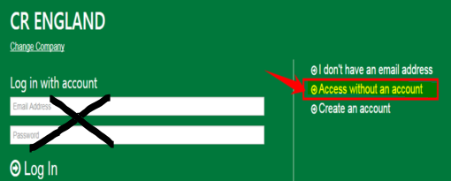

- Sign in using your Social Security # and DATE Of BIRTH OR Social Security and Last Name

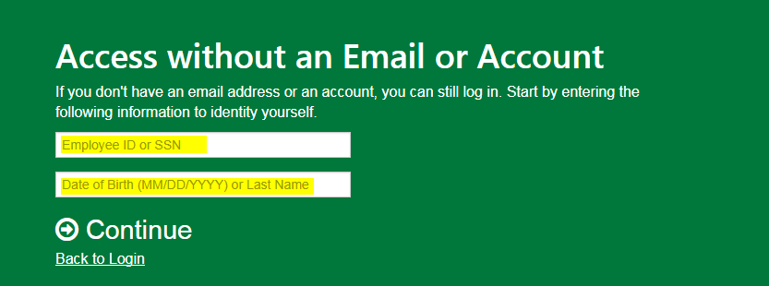
- You will be asked to verify your identity by selecting one of the following -
  - Send a verification code to your email on file
  - send a text to your phone # on file
  - Call your phone # on file
  - If the email or phone # shown do not match your current information, please email driverpayroll@crengland.com
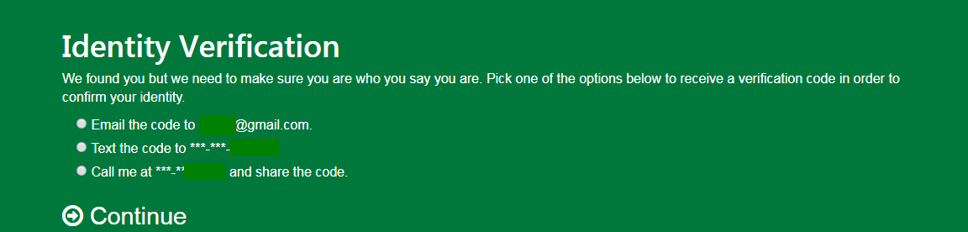

- Enter the Verification code and continue to view your tax form
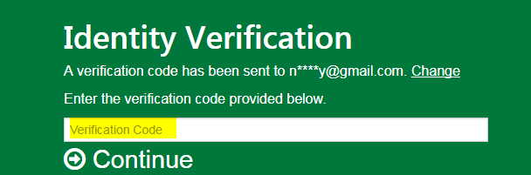

- Once logged in you will see your forms, If you have been at C.R. England more than 1 year, you may need to “Switch Company” to find the current year and toggle the View between 1095-C and W2
